**Project Design Phase-II**

**Data Flow Diagram & User Stories**

|  |  |
| --- | --- |
| Date | 14 October 2022 |
| Team ID | PNT2022TMID20272 |
| Project Name | IOT Based Smart Crop Protection System For Agriculture |
| Maximum Marks | 4 Marks |

**Data Flow Diagrams:**

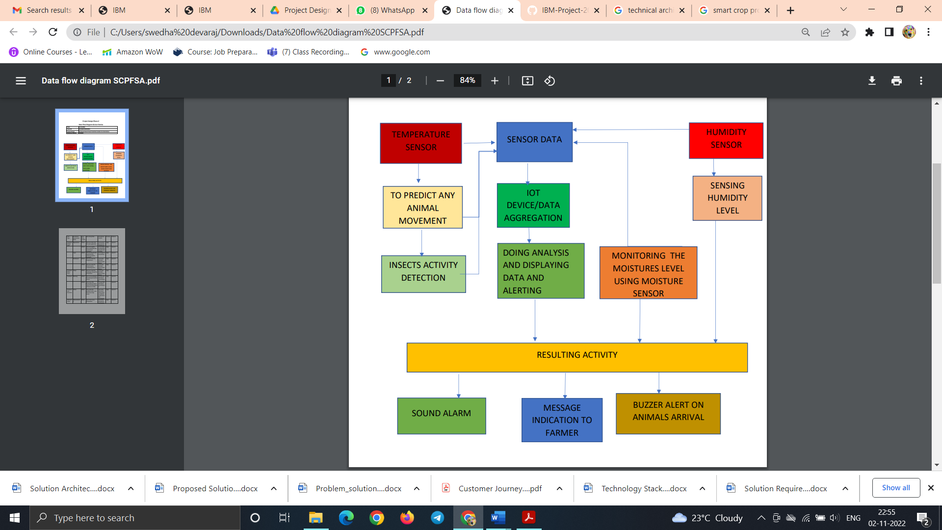

**User Stories:**

| **User Type** | **Functional Requirement (Epic)** | **User Story Number** | **User Story / Task** | **Acceptance criteria** | **Priority** | **Release** |
| --- | --- | --- | --- | --- | --- | --- |
| Customer (Mobile user) | Registration | USN-1 | As a user, I can register for the application by entering my email, password, and confirming my password. | I can access my account / dashboard | High | Sprint-1 |
|  |  | USN-2 | As a user, I will receive confirmation email once I have registered for the application | I can receive confirmation email & click confirm | High | Sprint-1 |
|  | Login | USN-3 | As a user, I can login into the application by entering email & password | I can Login to my account | High | Sprint-1 |
|  | Dashboard | USN-4 | User can view the temperature | I can view the data given by the device | High | Sprint-1 |
|  |  | USN-5 | User can view the level of sensor monitoring value | User can view the data given by the device | High | Sprint-2 |
| Customer (Web user) | Usage | USN-1 | User can view the web page and get the device | I can view the data given by the device | High | Sprint-3 |
| Customer | Working | USN-1 | User act according to the alert given by the device | I can get the data work according to work | High | Sprint-3 |
|  |  | USN-2 | User turns ON Buzzer/Sound alarm when the disturbance will occur on field | I can get the data work according to work | High | Sprint-4 |
| Customer Care Executive | Action | USN-1 | User solve the problem when some faces any usage issues | I can solve the issues when some one fails to understand the procedures | High | Sprint-4 |
| Administrator | Administration | USN-1 | User store every information | I can store the gained information | High | Sprint-4 |